Quick Start Guide

CashViewTM v1.0

(C) Copyright 2019 Sage Software Asia Pte Ltd

CONTENTS

Chapter 1: Introduction 1

Chapter 2: Setup Process 2

Chapter 3: Installation 3

Chapter 4: Entering license information 4

Chapter 5: Activating the module 5

Chapter 6: Entering Currency Rate 9

Chapter 7: Options settings 10

Chapter 8: Setting up Security 16

Chapter 9: First Data Calculation 17

Chapter 10: The Inquiry function 18

Chapter 11: Generating reports 23

Chapter 12: Where to go from here 24

Chapter 1: Introduction

Welcome to the Cash Flow Management module. This is an add-on module to your Sage 300 software.

Cash flow is vital in any business. Knowing whether you have enough cash to pay salary, rental, suppliers and the many other activities in your business has always been a challenge for businesses. Your investment in Sage 300 is a positive step to better managing your finances. An Accountant using Sage 300 would be able to tell if you have sufficient funds to run the business. For someone who does not have the time to scrutinize the numbers on a regular basis, you would wish for a better solution. A solution that looks at all the numbers and have them presented in an easily understood manner, with option to go into details, if so desired.

Cash Flow Management is designed with a dashboard approach to cash flow management. It’s simple and uncluttered interface hides all the complexities necessary to determine if there is a potential problem, projected into the future. It is a great tool if you just need a heads up indication of how your business is fairing and at the same time offers targeted details that you can immediately focus on.

To help you to get up and running quickly so that you can begin to benefit from this great tool, we have put together this guide. There is another document called User Guide that will have more details on how to operate this function, should you need it.

Chapter 2: Setup Process

The steps shown here are to be performed in the sequence shown. It is written to be concise so that you can get up and running as quickly as possible, leaving fine tuning to later when you explore the function.

*Notes: If you are a company registered in Singapore or Malaysian and your functional currency is not SGD or MYR then you are required to maintain exchange rates between SGD/MYR and your Functional currency. It would be ideal if these rates are maintained monthly so that the program will have reference to a current rate. If the rate does not vary much then it is perfectly acceptable to update rates as and when needed.*

Chapter 3: Installation

Although the installation procedure is simple and straightforward, we highly suggest that you seek the assistance of a Sage Business Partner to perform this task. This is to ensure that it is done correctly.

The *User Guide* has a chapter on Installation where you can learn more about this procedure.

Chapter 4: Entering license information

A license is needed to use this module. If you receive messages that the software is installed on a trial mode then it means that a permanent license has not been updated into the installation. Please contact your Sage Business Partner for assistance on how to obtain the license.

As this step is usually done during the installation of this program, your Sage Business Partner would have obtained the license prior to this. This step is documented here for your reference should you choose to perform the install yourself.

Chapter 5: Activating the module

Any module installed for use in Sage 300 has to be activated. Activation is the process of turning on a module for use with a company’s database. Sage 300 being a multi-company application, allows you to choose which feature is to be used for each company.

So, in the case of this Cash Flow Management module, you can choose to use it for one or more companies in your installation.

* To activate a module, go to *Administrative Services* and run *Data Activation*.

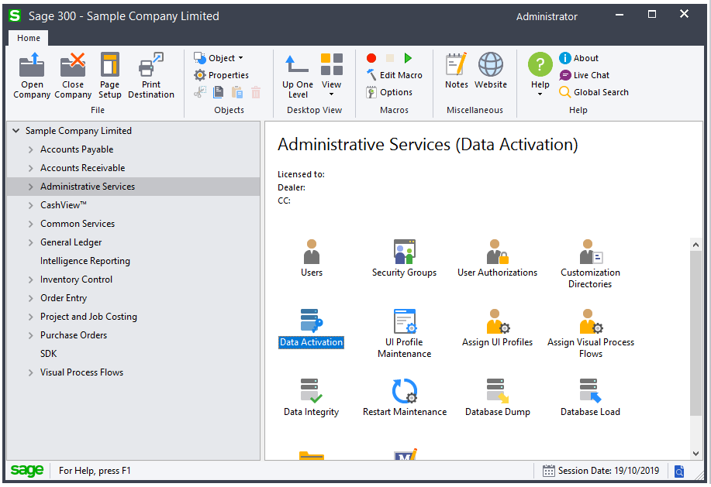

You will be prompted to perform a backup. This is in case you encounter a problem during activation and need to recover your system.

*Note: To deactivate (uninstall) this module after it has been used would require the assistance of your Sage Business Partner. There is no deactivation option in the system.*

* Check the checkbox and then click the Proceed button to move to the Activation selection screen.

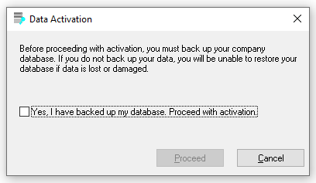

* In the Data Activation selection screen, you will see a list of modules that are installed in your installation but have yet to be activated. Select CashView module to activate and when the Next button is enabled, click on it.

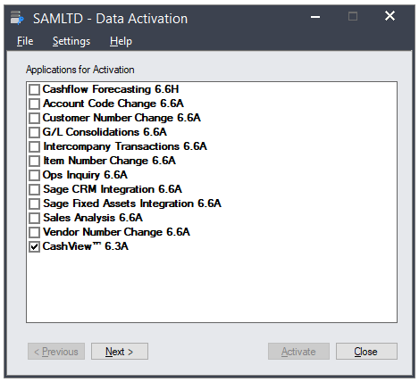

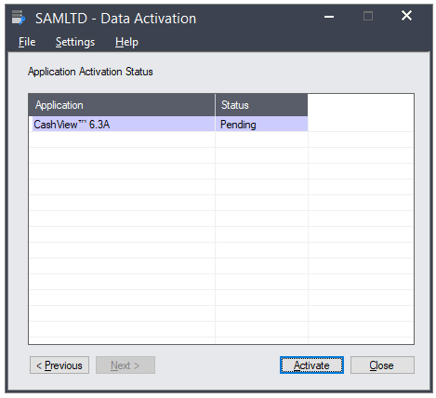

* To begin Activation, click on the Activate button.

Once successfully activated you will see the Status reflected in the Status Grid. Click the Close button to exit this function.

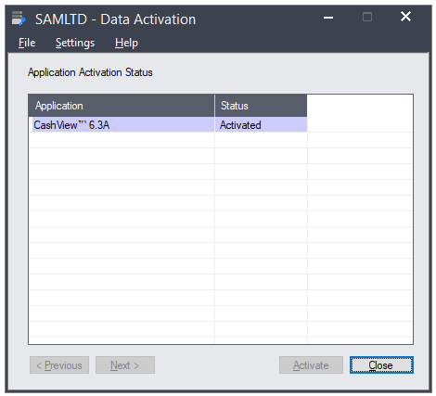

* You have now successfully activated the Cash Flow Management module. You should see this as a menu item in your Sage 300 system.

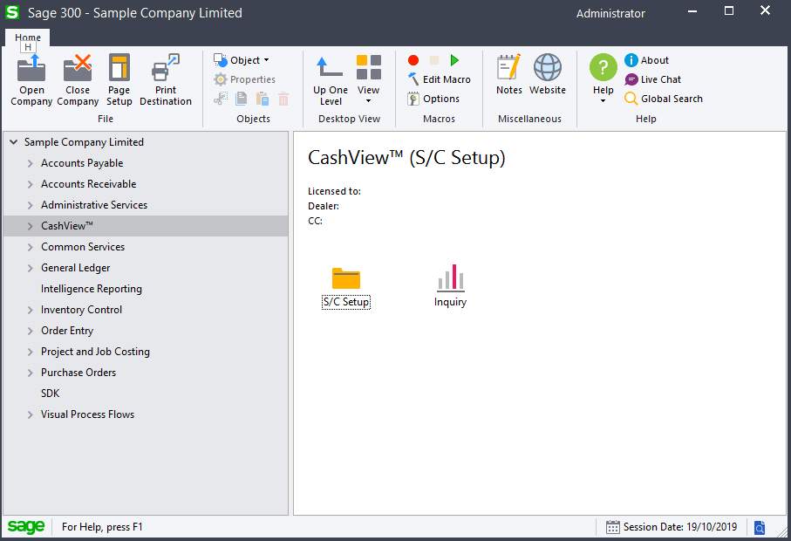

Chapter 6: Entering Currency Rate

* Skip this step if your business is registered in a country other than Singapore or Malaysia and go to Chapter 7.
* You need to set up exchange rates if your Functional Currency used is not the currency of the country you are in. For example, if you have selected Singapore as the Country in the Company tab of the Options screen and your Functional Currency is say, Canadian Dollars- CAD then you will need to go to the Common Services module and enter rates in the Currency Rates function in the Currency menu.

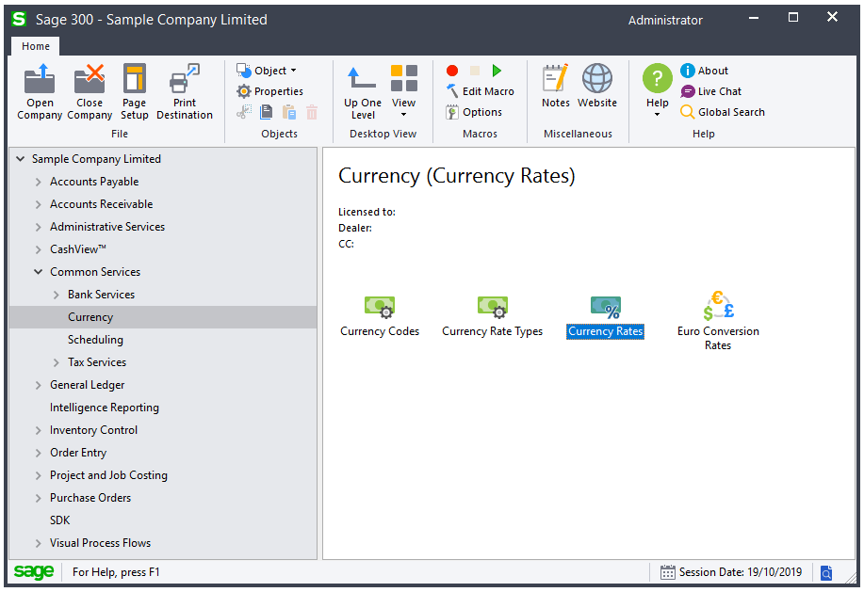

* In the Currency Rate function, create a rate entry FROM CAD to SGD (for example). You may choose the other rate options to suit your preference.

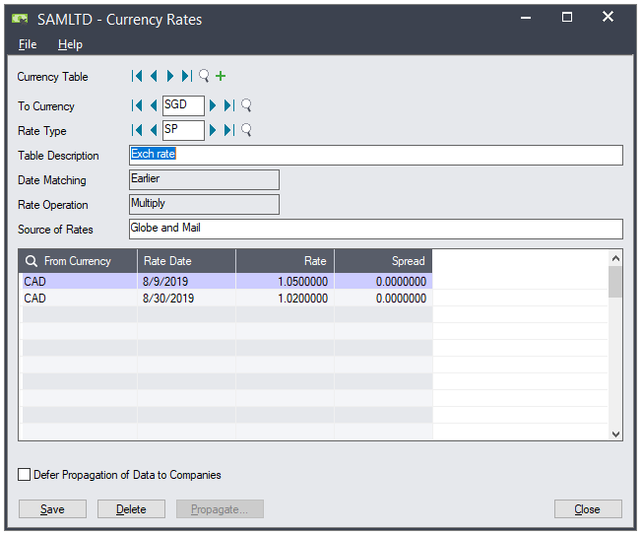

Chapter 7: Options settings

Before the Cash Flow function can be used, you are required to enter settings that are used by the program. This section explains briefly what the settings that you need to fill up. For more information on any of these parameters, please refer to the *User Guide*.

* To access this function, you can locate it in the Cash Flow Management menu under S/C Setup. The function is called Options.

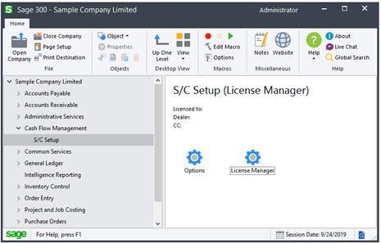

* Once you start Options, you will be presented with a screen that has a number of tabs. Let us review them and learn what need to do for each of them.

## Company

This describes your company and your business. You will notice that a few pieces of information have already been prepopulated for you. These are:

* Company Name
* Address
* Business Registration Number

All of these are taken from the Company Profile in Common Services. Here are the list of fields in this screen and what you need to fill for them. For full explanation of these fields, please refer to the *User Guide*.

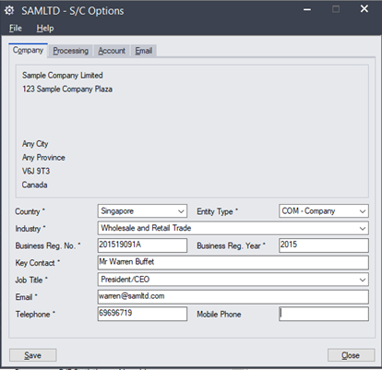

|  |  |
| --- | --- |
| Country | Select Singapore or Malaysia if your business is registered in these countries. For all others please choose “Others”. |
| Entity Type | Select one that is the closest match to your business. |
| Business Reg No | If you are in Singapore or Malaysia, you will enter the business registration number issued to you by your government. If you have selected “Others” in the above field then you can enter “None” here. |
| Business Reg Year | This is the number of years you have been in business. It is auto-populated if you have selected Singapore as the Country and you have entered a valid Business Reg No. If this is not automatically done or you have selected a country other than Singapore then just enter the year the business is registered. |
| Key Contact | Specify the CEO or the CFO information here. |
| Job Title | This is the title/appointment of the Key Contact. |
| Email | This is the email address of the Key Contact. |
| Telephone | This is the telephone number for the Key Contact. |
| Mobile Phone (Optional) | This is the mobile number of the Key Contact |

*Note: All fields marked with an “*” are required fields.*

## Processing

This screen defines some of the behavior you wish to apply.

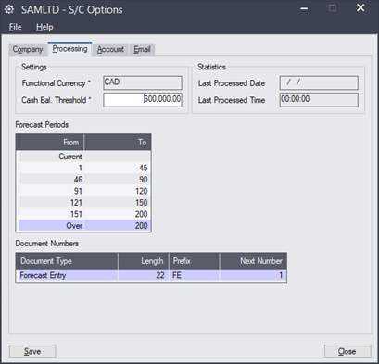

|  |  |
| --- | --- |
| Functional Currency | This is a display field only. It shows the currency used for this company database. |
| Cash Bal. Threshold | This is minimum desired cash balance you would like to achieve. |
| Last Processed Date | The last date when calculation of your cash flow is performed. |
| Last Processed Time | The last time when calculation of your cash flow is performed. |
| Forecast Periods | These are the forecast days’ ranges for cash flow. You can have up to 7 ranges. |
| **Document Numbers** |  |
| Document Type | Currently, there is only one document type supported. This is used for entry of Inflow and Outflow entries that are not reflected in your account balances. |
| Length | Indicate the length of the document number you wish to use. |
| Prefix | Specify the prefix used. |
| Next Number | Indicate the next running number to use. |

## Account

This screen shows all the Cash and Banks General Ledger accounts that are active. To determine whether a G/L account is of this type, they must be assigned to the Cash and Cash Equivalents group category. If your system has already been implemented then this would normally have been setup correctly or if you are using the Financial Reporter (FR) then it is also very likely that you have set them up correctly.

*Note: To learn how to assign G/L accounts to account groups please refer to your General Ledger User Guide.*

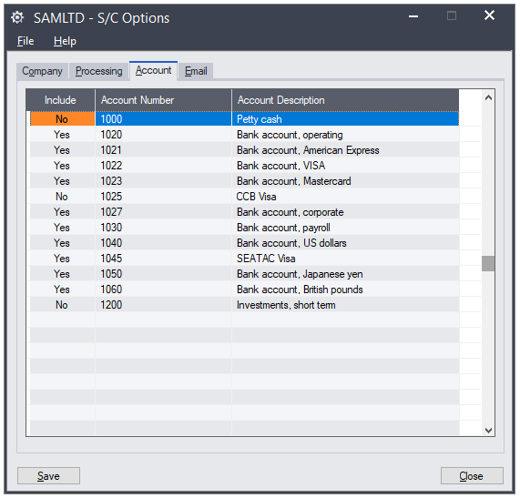

|  |  |
| --- | --- |
| Include | Toggle to Yes if you want to include balances from this account. |
| Account Number | This is not editable and shows Account number used. |
| Account Description | This is not editable and shows the Account description. |

## Email

This screen allows you to configure email settings so that the program can use it to notify you of threshold breached alerts. These settings are also used by the program when it sends you promotional messages.

*Note: Promotional messages are useful as they present opportunities for your business to take advantage of bank offers. You will need to opt in before these will be presented to you. If you have opted in and subsequently decide to opt out, you can come back to this function and turn off your consent.*

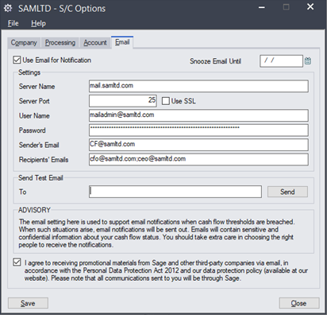

|  |  |
| --- | --- |
| Use Email for Notification | This will determine whether the system will send you an email when the threshold is breached. If you intend to use email for notification then you must configure the email settings in this screen. If you do not turn on this option, you can still receive on screen notification when you access the Inquiry function. |
| Snooze Email Until | Setting a date here will stop the sending of emails whenever a threshold alert occurs. This will be in force until this date has pass.  *Note: On screen snoozing is also available by user. This is done when you set snooze in the Inquiry screen.* |
| Server Name | Specify the email server name to use. You may need the assistance of your company’s IT staff to guide you on this. |
| Server Port | Specify the port used by your email server for send. |
| Use SSL | Specify if your email server uses Secured Socket Layer (SSL) for email send. |
| User Name | We use this email address to send emails to recipients of alerts and notifications. This should be a valid email account. |
| Password | This is the password for the email account that you specify. |
| Sender’s Email | This is the email account to show in any email sent for alerts and notification. |
| Recipients’ Emails | Specify the email IDs that will be receiving alerts and notifications. You separate them using a semicolon “;”. |
| To | This is used for testing of your email setting. Specify your email ID here to receive the test email. |
| Consent | This is to indicate whether you consent to receiving promotional emails from Sage and third-party companies that are working in collaboration with Sage. You can always change this, if desired. |

Chapter 8: Setting up Security

Security is defined in the Administrative Services under Security Groups. There are 6 areas that can be set to secure the use of this module.

*Note: Security is only enabled if you have turned it on for the company in Database Setup (DBSETUP) See Administrative Services User Guide for information on how to do this.*

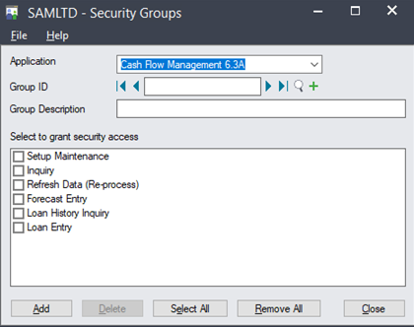

We recommend that you limit the use of this module only to employees that has a need to know as the information it displays are usually seen as highly confidential in businesses.

Here are our recommendations:

|  |  |
| --- | --- |
| **Rights** | **Who should have access to this** |
| Setup Maintenance | This should be set only for someone who can make decision on how the system behaves. We recommend a senior person in Finance. |
| Inquiry | People in the company that has a need to monitor cash flow status |
| Refresh Data (Re-process) | Person that can make changes to settings and need to see the immediate impact of these changes |
| Forecast Entry | Person that needs to maintain cash flow and need to enter financial and investment activities that are happening in the near future and that can affect cash flow projections |
| Loan History Inquiry | Applicable only to Singapore and Malaysia registered companies (See *User Guide* for more information) |
| Loan Entry | Applicable only to Singapore and Malaysia registered companies (See *User Guide* for more information) |

*Note: For detailed information on any of these settings please refer to the User Guide. Sage 300’s ADMIN account is automatically set to have rights to all options.*

Chapter 9: First Data Calculation

In order for the correct information to be displayed in the Inquiry screen, data has to be extracted and processed for the display. First you need to make sure all the right settings are made in Settings/Options.

Then, when you run the Inquiry function, calculations will be triggered. This process can take a few seconds to a few minutes, depending on the size of your data.

*Note: This method is also triggered each day by the first user logging in to this company’s data. A typical 1 GB database takes approximately 8-10 seconds.*

The Dashboard screen in the Inquiry function also has a Refresh button. Clicking this will force a re-calculation. To do this you will be required to have the appropriate access rights (See Chapter 8 for more information).

There is a small difference between a calculation triggered manually in the Dashboard and the calculation done by the first user logon. The latter will trigger email notifications for threshold and third-party notifications and the former will just refresh the display.

Chapter 10: The Inquiry function

The Inquiry function can be found in the Cash Flow Management module menu. It is called Dashboard.

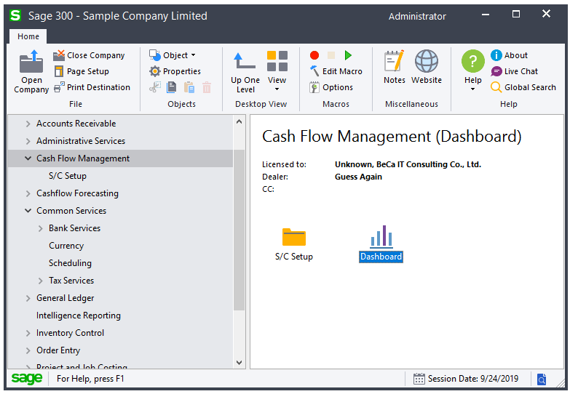

When you run this function, the first screen that you see would depend on a number of conditions occurring in your system.

These are the possible screens available to you:

Companies set up with “Singapore” and “Malaysia” as country

Menu available:

* Info Center

This is the menu where you can see any current alert and promotional messages. Messages appear when you come into the function. These can be dismissed. However, you can use this menu option to view them at any time. Promotional messages are currently only available for Singapore and Malaysia.

* Dashboard

This is the heart of the Cash Flow Management function. You will find a number of metrics that will give you a quick status of your cash flow. For example, the Current and Quick Ratio metrics are measured against the base of 1.1 and 1.0 (you can change this to suit your business – See *User Guide* for information on how to change this). Metrics are useful indicators without having to look at details.

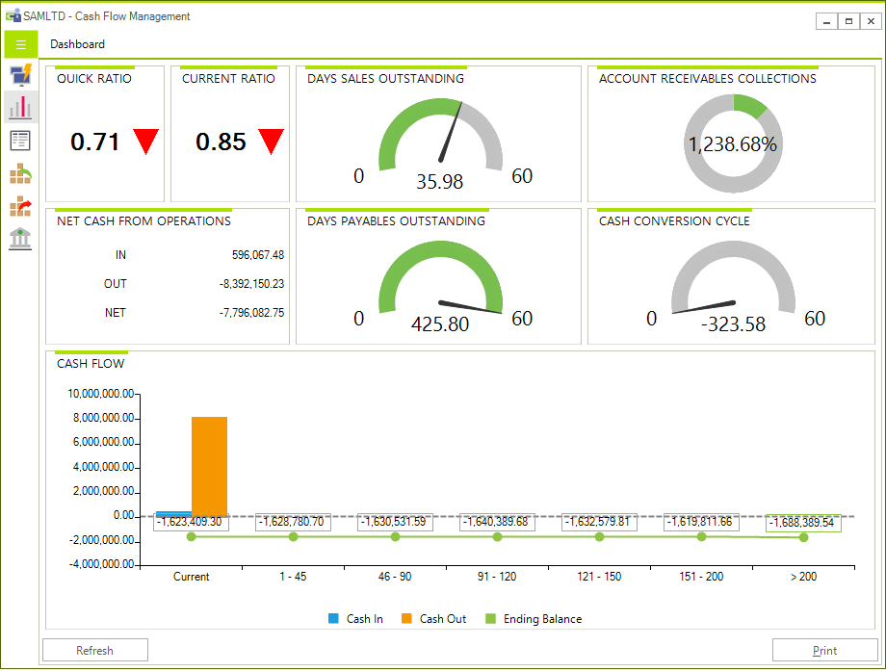

* Cash Flow Summary

You can monitor your Cash flow forecasted over seven days’ ranges. You can also enter amounts for Inflow and Outflow. These are typically financial activities are yet to be recorded in your accounting data. (See Inflow and Outflow entry later for information on how to enter the amounts).

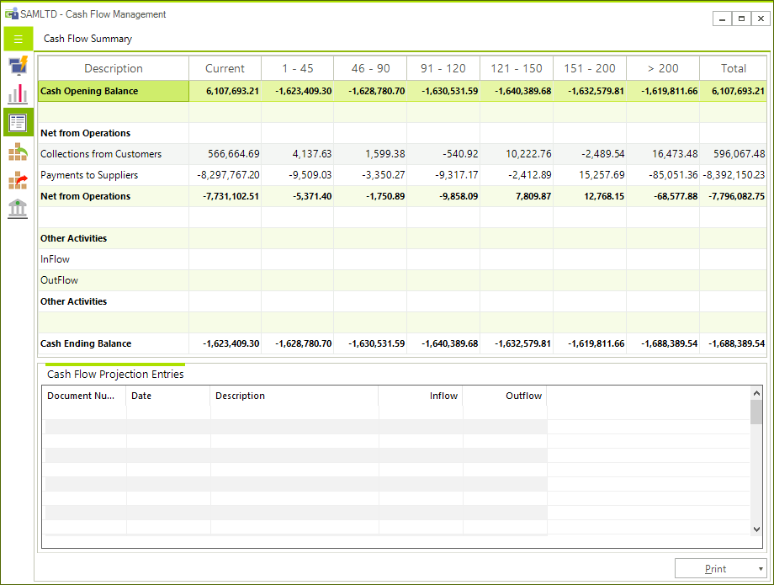

* Entering Inflow and Outflow Entries

You do this by clicking in the entry Grid found below the Cash Flow Summary grid. Use the INSERT key (INS) to insert a new row, if clicking in it does not automatically do so. Enter an effective date, description and the Inflow or Outflow amount. The system will use the Effective Date to determine which bucket it will be displayed.

* A/R Summary – Top 10 Outstanding Balance

This highlights the ten customers with the highest outstanding balances. It also shows the credit limit extended to them and their past highest outstanding balance.

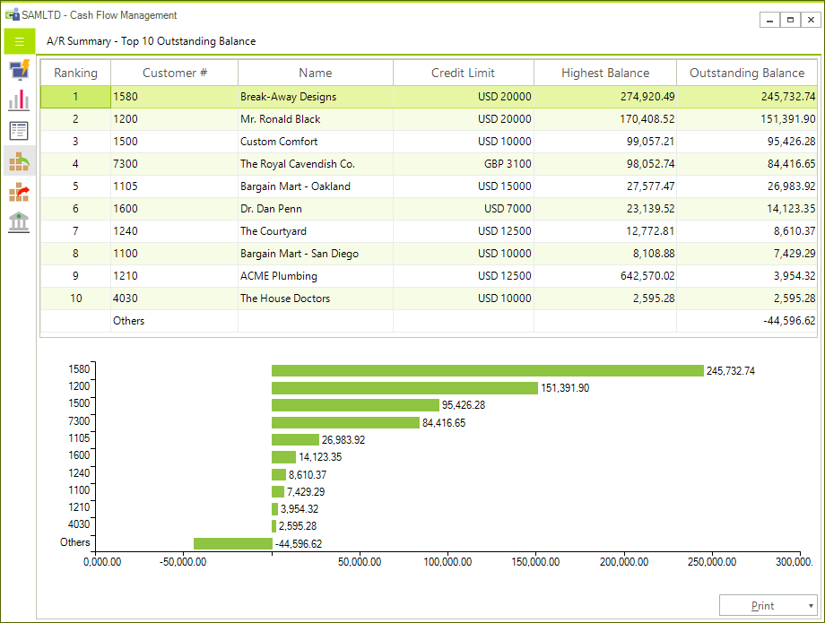

* A/P Summary = Top 10 Outstanding Balance

This is similar to the Top 10 Customers by Outstanding balances.

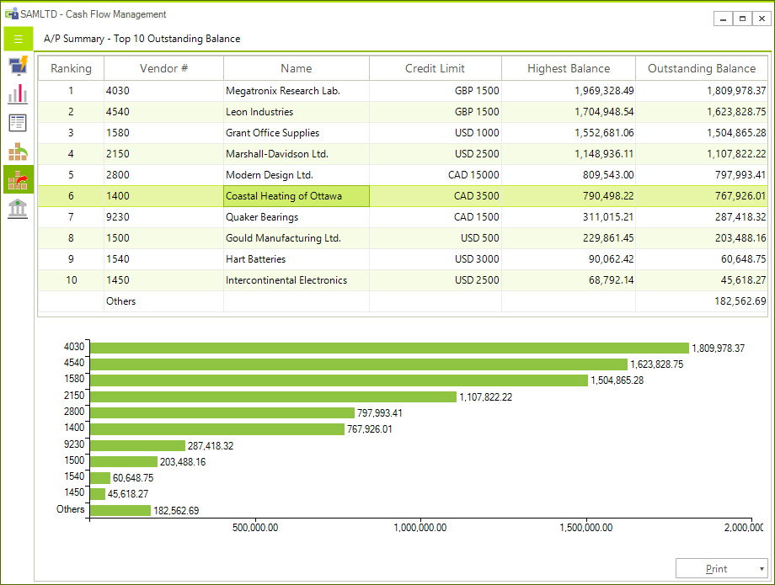

* Loans

Any loans activities. For more details on this please refer to the *User Guide*.

Companies set up with “Others” as country

Menu available:

* Info Center

This is where you can view the Alert message that tells you about your cash flow exceeding the threshold set. It will not contain any Promotional message.

* Dashboard

This is the heart of the Cash Flow Management function. You will find a number of metrics that will give you a quick status of your cash flow. For example, the Current and Quick Ratio metrics are measured against the base of 1.1 and 1.0 (you can change this to suit your business – See *User Guide* for information on how to change this). Metrics are useful indicators without having to look at details.



* Cash Flow Summary

You can monitor your Cash flow forecasted over seven days’ ranges. You can also enter amounts for Inflow and Outflow. These are typically financial activities are yet to be recorded in your accounting data. (See Inflow and Outflow entry later for information on how to enter the amounts).



* Entering Inflow and Outflow Entries

You do this by clicking in the entry Grid found below the Cash Flow Summary grid. Use the INSERT key (INS) to insert a new row, if clicking in it does not automatically do so. Enter an effective date, description and the Inflow or Outflow amount. The system will use the Effective Date to determine which bucket it will be displayed.

* A/R Summary – Top 10 Outstanding Balance

This highlights the ten customers with the highest outstanding balances. It also shows the credit limit extended to them and their past highest outstanding balance.



* A/P Summary = Top 10 Outstanding Balance

This is similar to the Top 10 Customers by Outstanding balances.



Chapter 11: Generating reports

Various reports are available in the Options and Inquiry function. These are the reports that you can print from this function.

|  |  |  |  |
| --- | --- | --- | --- |
| **Function** | **Description** | **Location** | **Report Name** |
| Options | Cash Management Option Settings | File/Print menu | SCOPT |
| Inquiry | Cash Flow Management Dashboard Report | Dashboard | SCSUM01 |
| Inquiry | Cash Flow Management Summary Report | Summary | SCSUM03 |
| Inquiry | Cash and Banks | Summary | SCCABK |
| Inquiry | Activities from Financing and Investment Activities | Summary | SCINOUT |
| Inquiry | A/R Top 10 Customers by Outstanding Balance | A/R Summary | SCARTOP |
| Inquiry | A/R Receivables Forecast | A/R Summary | SCARAGED |
| Inquiry | A/P Top 10 Vendors by Outstanding Balance | A/P Summary | SCAPTOP |
| Inquiry | A/P Payables Forecast | A/P Summary | SCAPCASH |

For details on these reports please refer to your *User Guide*.

Chapter 12: Where to go from here

Congratulations! You have successfully configured your Cash Flow Management function. We suggest that you spend time to orientate yourself with the various metrics reflected in the dashboard and in the various screen in the function.

The reports available are also a good source of useful and important information about your cash flow status. We highly recommend that you spend some time to review the *User Guide* so that you can understand the full workings of this module.